**Team Members:** Thomas Bock, Ammar Ahmed, Tan Hua, Jan Michael Golez

.

**Group Meeting Minutes:**

* Integration between software/Machine Vision:
* Construction of Laser Shroud
* Extension/Shortening of wires
* Mount the control boards
* Mount the Camera
* Plans for Laser Housing will be halted, instead the main focus will be directed towards integrating of all four individual parts
* A suggestion of replacement towards the microcontroller will be in discussion.
* New Software Implementation: Rasterization, and Inkscape
* Plans for assisting on the software once both mechanics and laser are done.
* Discuss group meetings for possible future problems arising with this project.

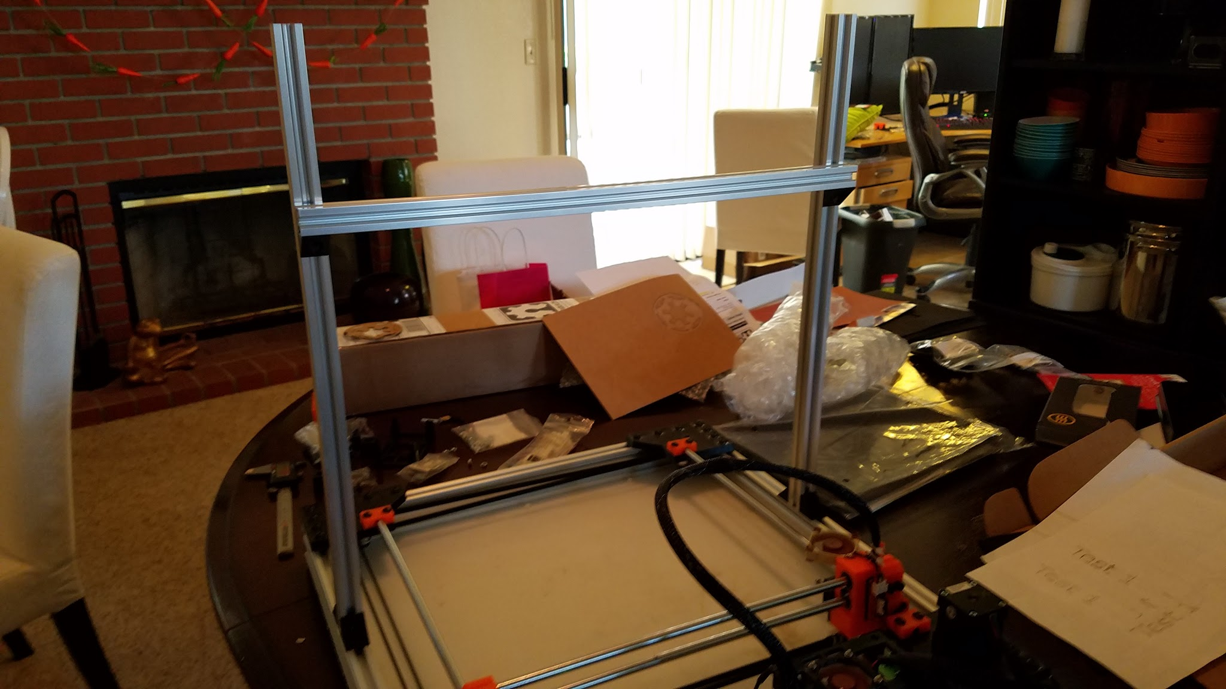

Camera mounting rail

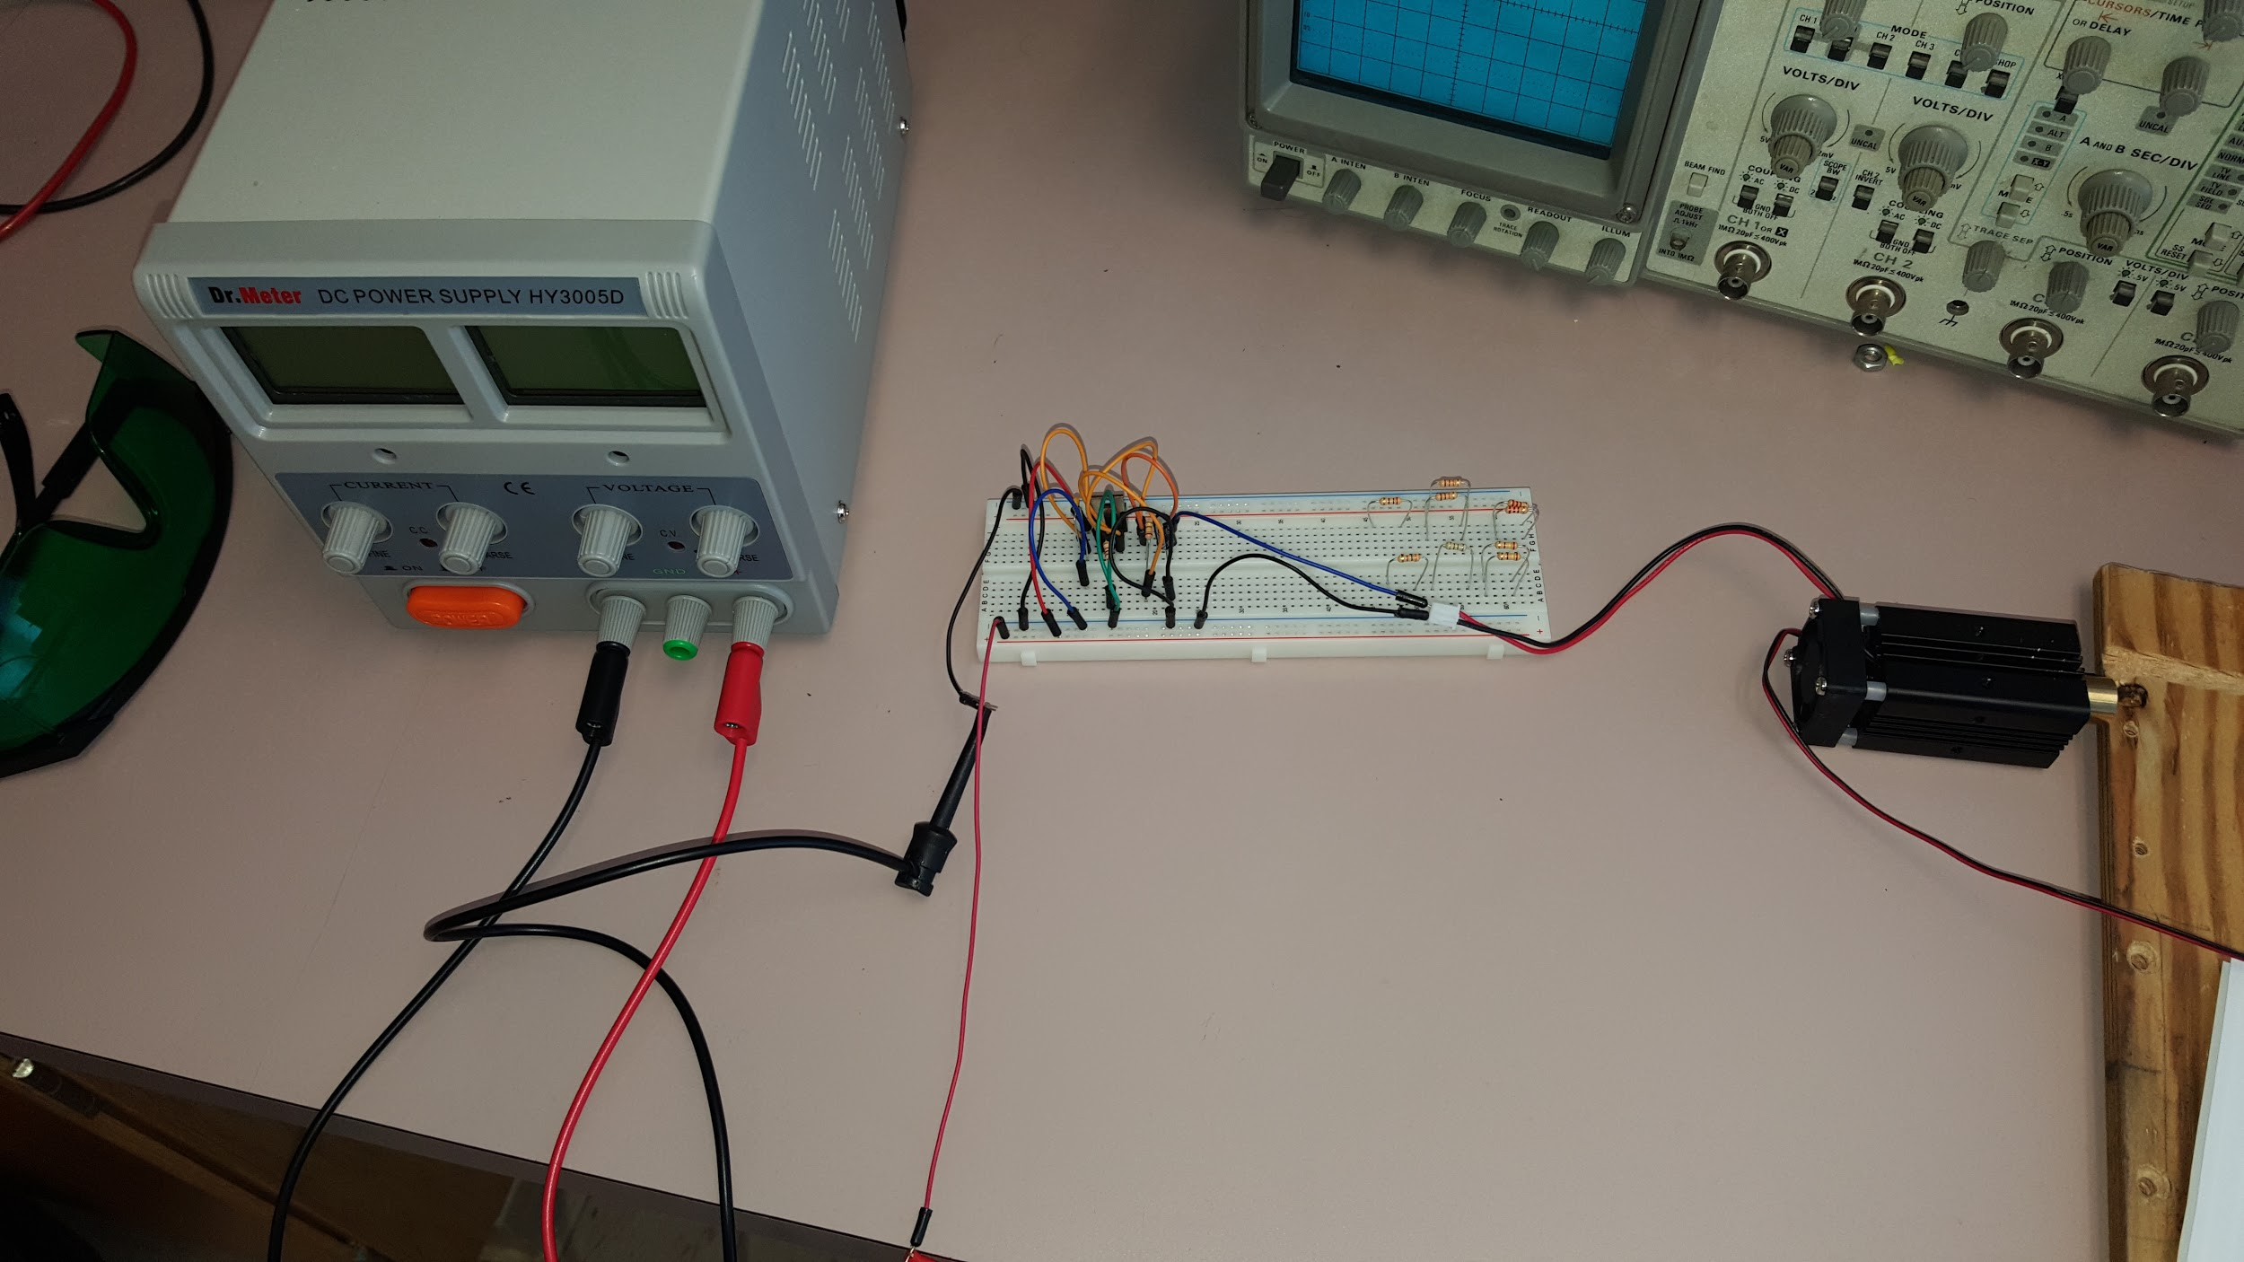

Prototype Laser Diode Driver.

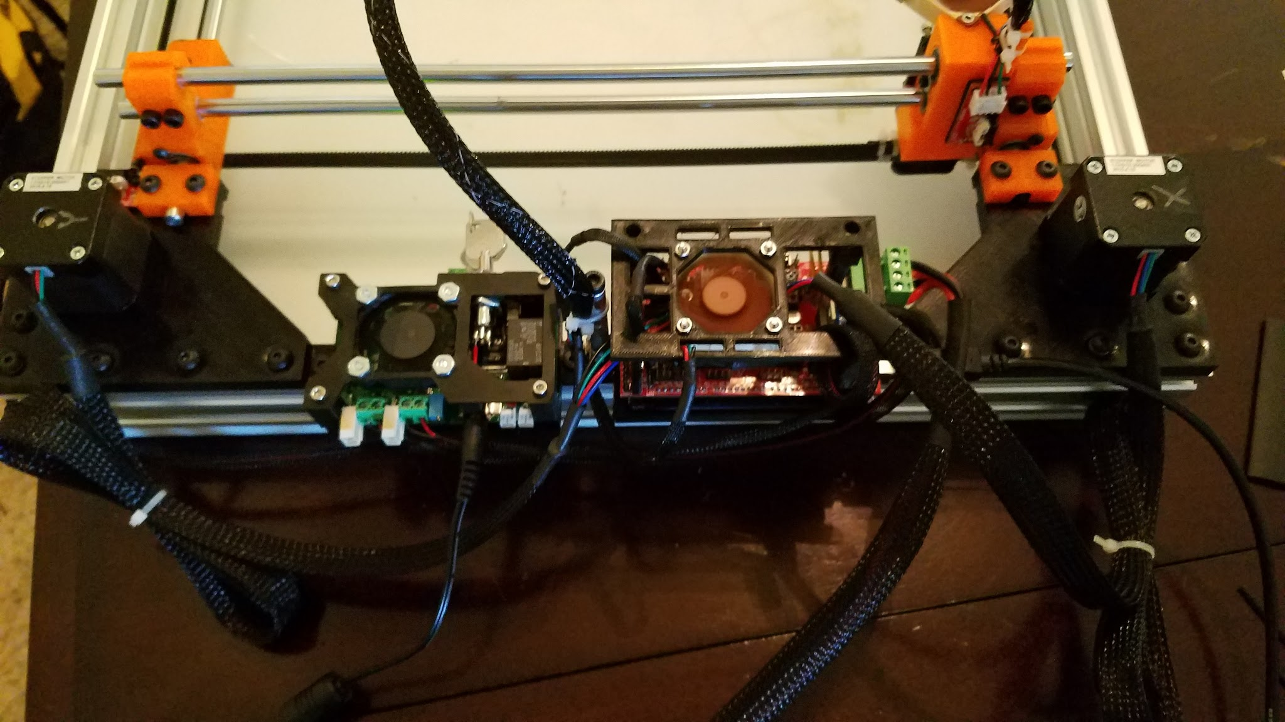

2.5 Amp Adjustable Safety Compliant Laser Diode Driver ;Ramps Board; Mounted to frame

**Summary of Team Tasks Assigned:**

1. Mechanics
2. Design and Assemble Camera mounting
3. Laser Diode
   1. Prototype Laser Diode: Vary voltage to reproduce constant current source on the laser driver.
   2. Start understanding the pint out on the base microcontroller on the CNC LASER to help integrate the laser with the mechanics and software
   3. Learn to use the COMpliant Laser Diode Driver for future enhancements on the CNC LASER.
4. Software
5. Complete process from design to execution
6. Computer Vision
   1. Work on algorithm for edge detection( needed for dimension detection)

**Summary of Team Accomplishments:**

1. Mechanics
2. Design and Assemble Camera mounting
3. Laser Diode
4. Prototype Laser Diode works in conjunction with the 500mW laser, final test needs to be done on the 2W laser
5. Compliant Laser Diode Driver was used to enhance compatibility with CNC Laser
6. Began understanding the pinouts on the Ramps board.
7. Software
8. Cutting mechanism worked well and followed the G-code instruction
9. Figured how to assign coordinates values from machine vision to input to inkscape
10. Computer Vision
11. An algorithm was found for filling circular objects but still working on the drawing box around the detected object.

**Tasks Assigned for Next reporting period:**

1. Mechanics
   1. Design and Build Camera mount
2. Laser Diode
3. Focusing more on helping the team with software integration
4. Begin research on PIN junction to better understand the functionality of the laser
5. Revision of documents
6. Software
7. Rasterizing mechanism
8. Computer Vision
   1. Resolve the issue by finding the algorithm for filling the gaps or drawing a box around the detected object

**Issues:**

1. Rasterizing was not able to work properly.
2. Laser with Software: TTL integration with the board was not working; Laser Pinout was communicating with the Laser Diode( it wasn't turning on)
3. Camera Vision with Software: the camera couldn't detect dimensions and be outputted towards an Excel file
4. Although 1st integration was successful, we need to be able to ensure all four parts communicate. This will require thorough analysis and lots of debugging.
5. Testing M

**Individual Summary (cont.)**

**Name:** Thomas Bock

**Tasks Assigned for this reporting period:**

1. Design and Assemble Camera mounting

**Accomplishments this reporting period:**

1. Design and Assemble Camera mounting
2. Mounted control boards
3. Cleaned up wiring
4. More tests completed with cutting various materials

**Issues:**

1. Parts shipment was incorrect by company, still waiting for some brackets, but can proceed without them for the time being.

**Tasks Assigned for Next reporting period:**

1. Integrate camera into rest of system.

**Individual Summary (cont.)**

**Name:** Jan Michael Golez

**Tasks Assigned for this reporting period:**

1. Prototype Laser Diode: Vary voltage to reproduce constant current source on the laser driver.
2. Start understanding the pint out on the base microcontroller on the CNC LASER to help integrate the laser with the mechanics and software.
3. Learn to use the COMpliant Laser Diode Driver for future enhancements on the CNC LASER.

**Accomplishments this reporting period:**

1. Prototype Laser Diode works in conjunction with the 500mW laser, final test needs to be done on the 2W laser .
2. Compliant Laser Diode Driver was used to enhance compatibility with CNC Laser
3. Began understanding the pinouts on the Ramps board.

**Issues:**

1. No issues arose this week, exception of software, better comprehension on the subject of the rasterization
2. Power distribution, will it be distributed equally?

**Tasks Assigned for Next reporting period:**

1. Focusing more on helping the team with software integration.
2. Begin research on PIN junction to better understand the functionality of the laser
3. Revision of documents.

**Individual Summary (cont.)**

**Name:** Tan Hua

**Tasks Assigned for this reporting period:**

1. Complete process from design to execution

**Accomplishments this reporting period:**

1. Cutting process worked well.
2. Was able to locate the object coordinates from camera on inkscape

**Issues:**

1. Rasterizing didn’t work.

**Tasks Assigned for Next reporting period:**

1. Complete rasterizing process
2. Do more testing with different design to improve performance

**Individual Summary (cont.)**

**Name:** Ammar Ahmed

**Tasks Assigned for this reporting period:**

1. Calibrating the camera to get dimensions in real world unit.

**Accomplishments this reporting period:**

1. Calibration is still in progress. The parts that will be used for mounting the camera were shipped and already delivered. The mounting bars for the camera are done and will start the calibration process this week.
2. Discussed with Tan about interfacing my program with his. After discussion, we agreed that it will be entered manually after getting the dimensions from my program.

**Issues:**

1. No issues so far.

**Tasks Assigned for Next reporting period:**

1. Continue calibrating the camera to get dimensions in real world unit.
2. Integrating the camera with the whole system.